**Documentation Report**

**Name Project:** Predictive Analytics for Students Successes.

**1.Inroduction:** This project aims to apply artificial intelligence and machine learning techniques to analyze student data and predict academic outcomes. By using a Neighbors Classifier algorithm, the model identifies students who are at risk of dropping out or underperforming. This early identification allows for timely and targeted interventions. The project is crucial in the educational sector as it helps institutions proactively support students, thereby enhancing their chances of academic success and improving overall educational outcomes...

Business Goal: The goal is to identify students who are at risk of dropping out or underperforming.

**2.** **Requirements:**

Type Data: in this project we used the numerical data of students.

Technical Requirements: Jupiter notebook, Colap, VS.

**3.** **Project Structure:** in this project we used the **CRISP_DM** Methodological Steps:

* 1. [Business Understanding](https://github.com/ahmealaa123/Student_Preformance_Prediction_Project/blob/1ae3a335b456f8f51d3cb8906c9246ca860e0037/#1.Business_Understanding)
* 2.[Data Understanding](https://github.com/ahmealaa123/Student_Preformance_Prediction_Project/blob/1ae3a335b456f8f51d3cb8906c9246ca860e0037/#2.Data_Understanding)
* 3.[Data Preparation](https://github.com/ahmealaa123/Student_Preformance_Prediction_Project/blob/1ae3a335b456f8f51d3cb8906c9246ca860e0037/#3.Data_Preparation)
* 4.[Modeling](https://github.com/ahmealaa123/Student_Preformance_Prediction_Project/blob/1ae3a335b456f8f51d3cb8906c9246ca860e0037/#4.Modeling)
* 5.[Evaluation](https://github.com/ahmealaa123/Student_Preformance_Prediction_Project/blob/1ae3a335b456f8f51d3cb8906c9246ca860e0037/#5.Evaluation)
* 6.[Deployment](https://github.com/ahmealaa123/Student_Preformance_Prediction_Project/blob/1ae3a335b456f8f51d3cb8906c9246ca860e0037/#6.Deployment)

**4.** **Version Control System (VCS) Logs:**

Track code changes using Git.

Ex Log: "update the model Algorism 2024/15/10 "

**4.** **Configuration Management:**

Configuration:

Python 3.4, gradio

**5.** **Testing and Validation:** we use always Testing with a clouds App such as (TruEra) An Validation.

**6.** **Results and Conclusions:** the final result now for app and model of Very Good in Predict, and the

test cases:

1.Test case1: the student degree is very good and he is not in the Risk: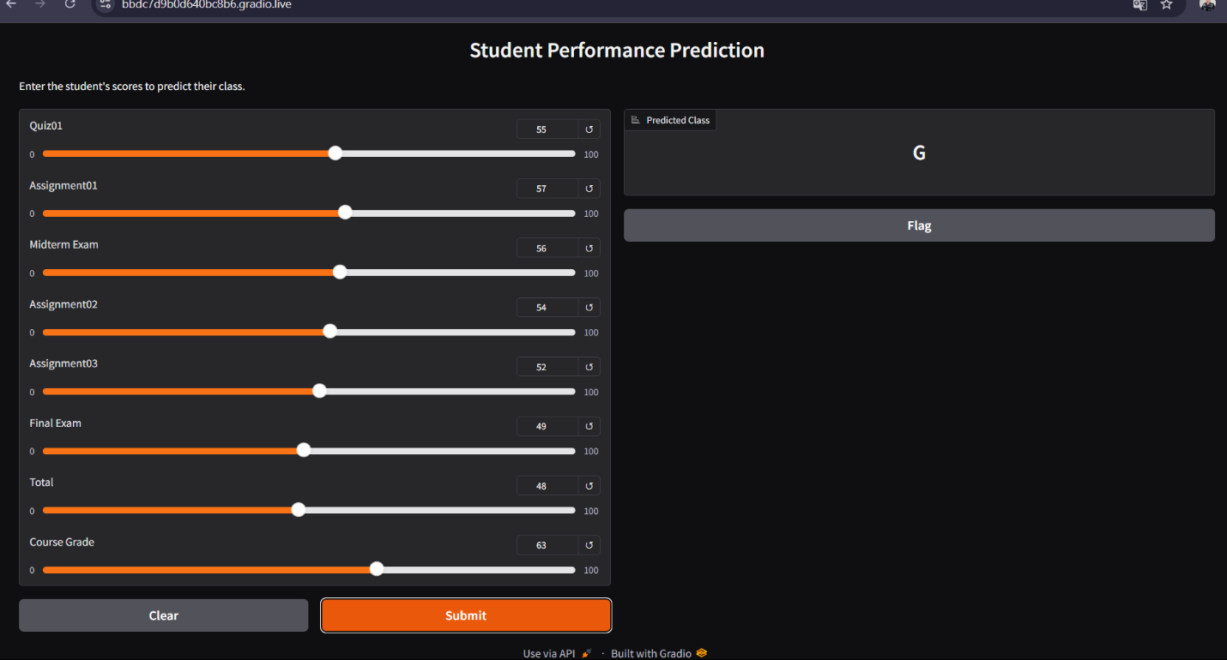

2.Test case tow: the student degree in the Risk: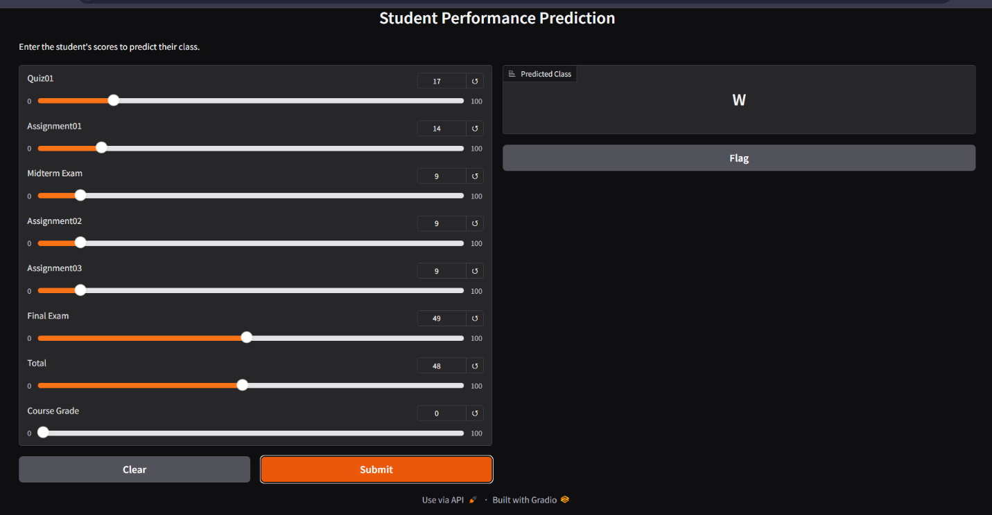

**7.** **Future Work and Improvements**: we need in the future make maintenance in the model such as make Collect more the data an retrain the model on this new data and monitoring the model in the work environment for sure of model not have any problem about the prediction.

**8.Project App(**[**Link**](https://c7b63916da80d347cd.gradio.live)**)**